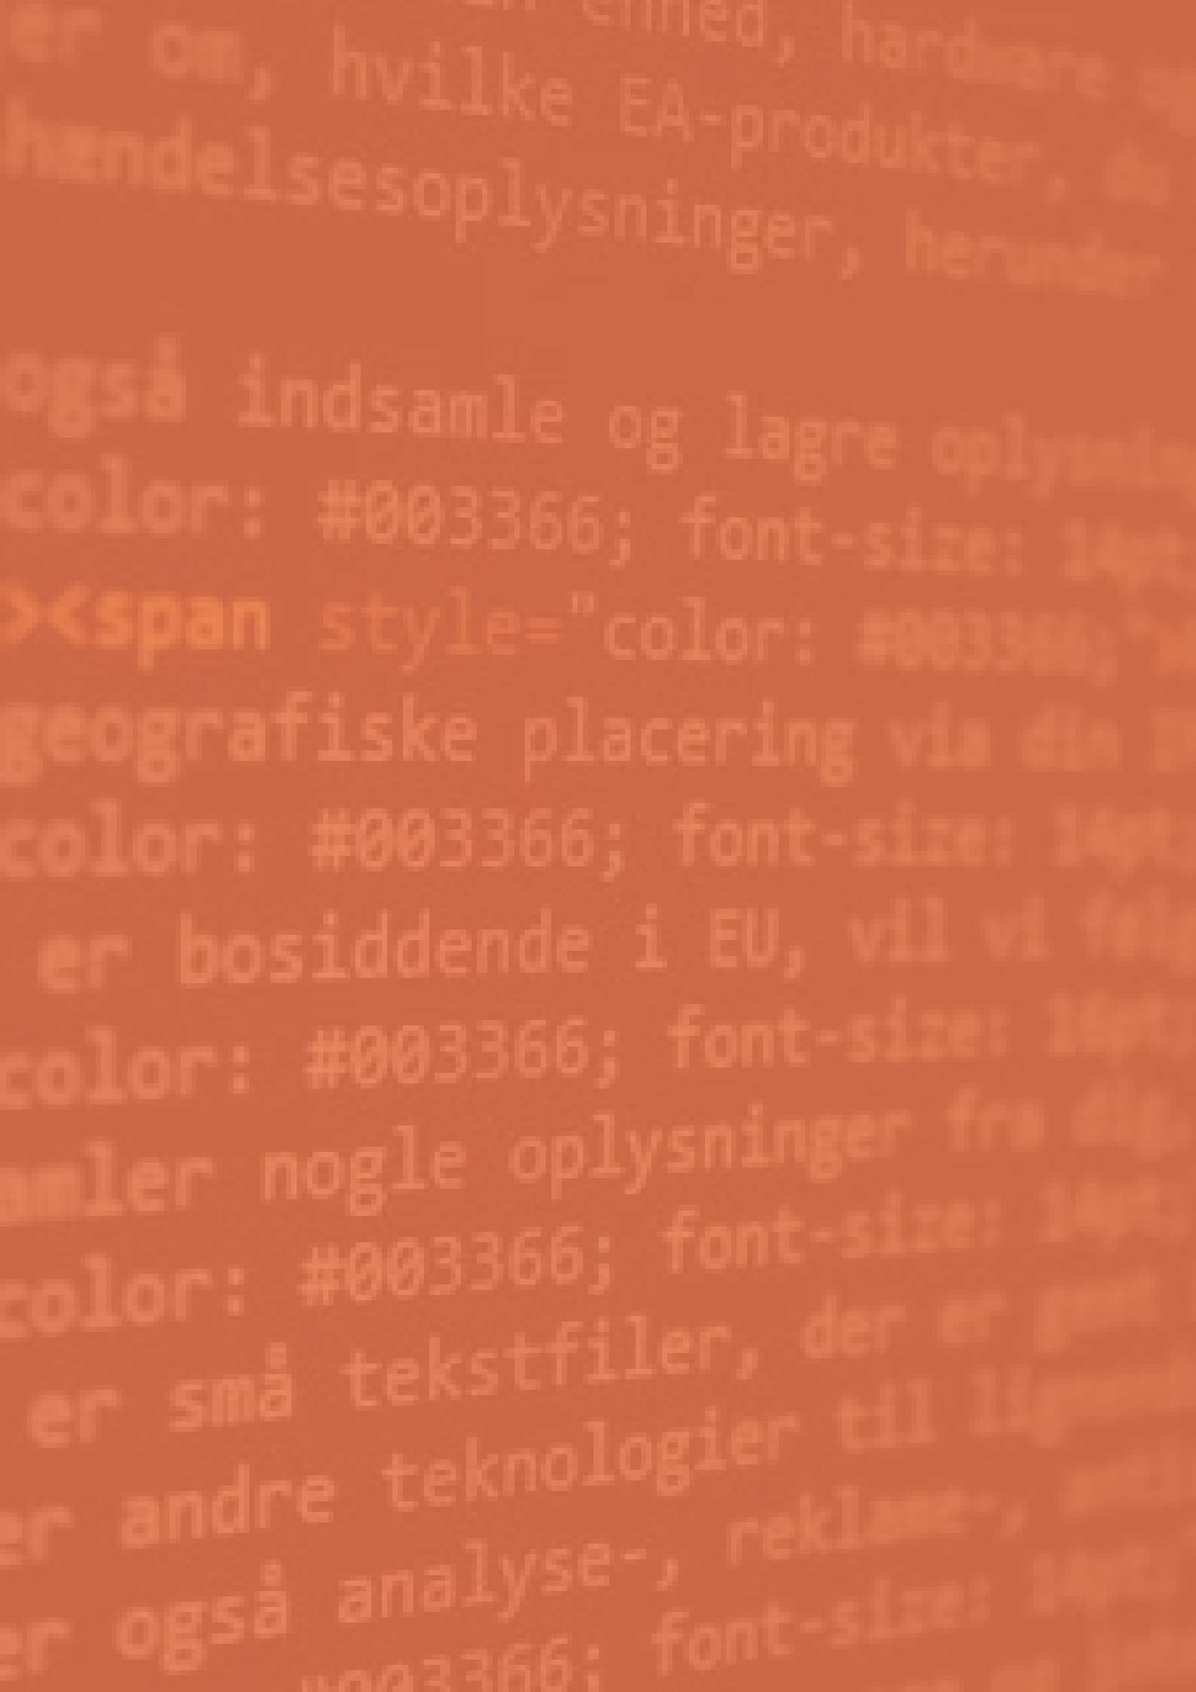

DROWSINESS DETECTOR

**Online Meeting Apps**

PREPARED BY: VIVEK KUMAR AHIRWAR

191112419

AYUSH PATEL 191112253

PARTHESH GUPTA

191112231

# Description

Our Project is based on the fact that now a days in online classes students feels drowsy and they take power nap or sometimes just go to sleep, also some students just turn on class and does their own work.

# Implementations

There are many implementations of our product other than using it in online classes, some are as follows: -

## Online Classes Office Employees

## Female Security Guard Sleeping At Workplace. CCTV Surveillance Stock Photo, Picture And Royalty Free Image. Image 111301296.

Office employee also sometimes feels drowsy while doing continuous work. If our product will be applied in offices than we can have a watch on employees and the boss can warn them.

Students now a days are attending online classes and while attending lots of time they go to sleep. Teacher will not able to know that a particular student is sleeping or not.

## Drowsy Driving

## 

A 2014 AAA Traffic Safety Foundation study found that 37 percent of driver’s report having fallen asleep behind the wheel at some point in their lives. An estimated 21 percent of fatal crashes, 13 percent of crashes resulting in severe injury and 6 percent of all crashes, involve a drowsy driver.

**System Requirements**

Recommended System Requirements

Processors: intel® Core™ i5 processor

RAM Required: 4 GB

Disk space: 2 to 3 GB

Operating systems: Windows® 10, macOS*, and Linux*

Working webcam

Minimum System Requirements

Processors: Intel® Core™ i3 processor

RAM Required: 2 GB

Disk space: 1 GB

Operating systems: Windows 10 Working webcam

**Software Dependencies**

**Main:**

Python 3.6.0

PyCharm

**Optional :**

Microsoft Teams

ZOOM

Google Meet

**Library Used**

Opencv-python

Dlib

Scipy

Playsound

Os

Time

distance

## FEATURES IMPLEMENTED:

## 

* Real time image processing using webcam
* Face Detection and Face Landmark Detection
* Detection of person’s drowsiness with use of EAR ratio
* Play alarm when person is drowsy
* If person is drowsy for some duration then online meeting apps will be closed
* If student is not present in front of screen then turn off online meeting apps

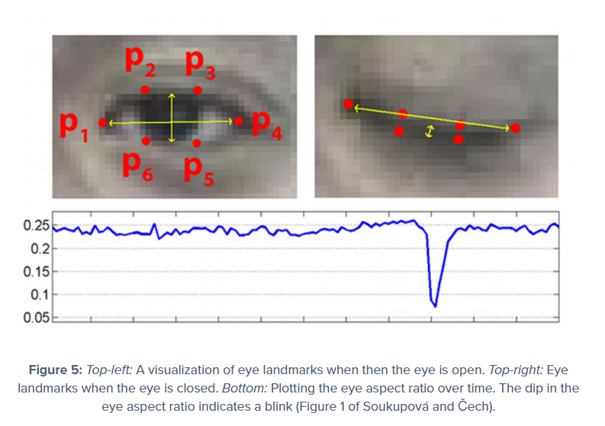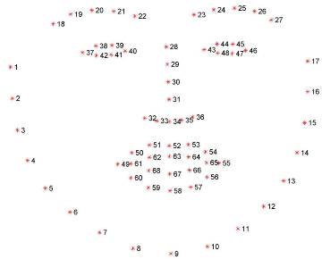

## SUGGESTIONS TO BE IMPLEMENTED:

* Implementing file handling
* If student is not present in front of screen then turn off online meeting apps
* If eye is just blinking then alarm should not be triggered
* To calculate and detect Yawn
* To find dlib alternate